CSA1505 - CLOUD COMPUTING AND BIG DATA ANALYTICS
Experiment-4
- Create a simple cloud software application for Property Buying & Rental process (In Chennai city) using any Cloud Service Provider to demonstrate SaaS include the necessary fields such as Buy, Rent, commercial, Rental Agreement , Rental Agreement, Area, place, Range, property value etc.

AIM:
To develop a simple Property Buying & Rental System using Zoho Creator (Cloud Service Provider) to demonstrate the Software as a Service (SaaS) model. The application helps users manage property buying and rental information in Chennai by recording customer and property details.
PROCEDURE:
Log in to Zoho Creator.
Create a new application named Property Buying & Rental System.
Design a form with the following fields:
- Customer Name
- Mobile Number
- Email ID
- Property Type (Buy / Rent)
- Property Category (Residential / Commercial)
- Rental Agreement (Yes / No)
- Area (sq.ft)
- Place (Anna Nagar, Adyar, Velachery, Tambaram, OMR, Porur, etc.)
- Budget Range
- Property Value
- Registration Date
- Booking Status
Configure the required drop-down lists, radio buttons, and text fields.
Create workflows to:
- Automatically set the Registration Date to the current date and time.
- Automatically set the Booking Status to Available.
Save and publish the application.
Enter sample customer and property details.
Verify that the property details are stored correctly and that workflows execute successfully.
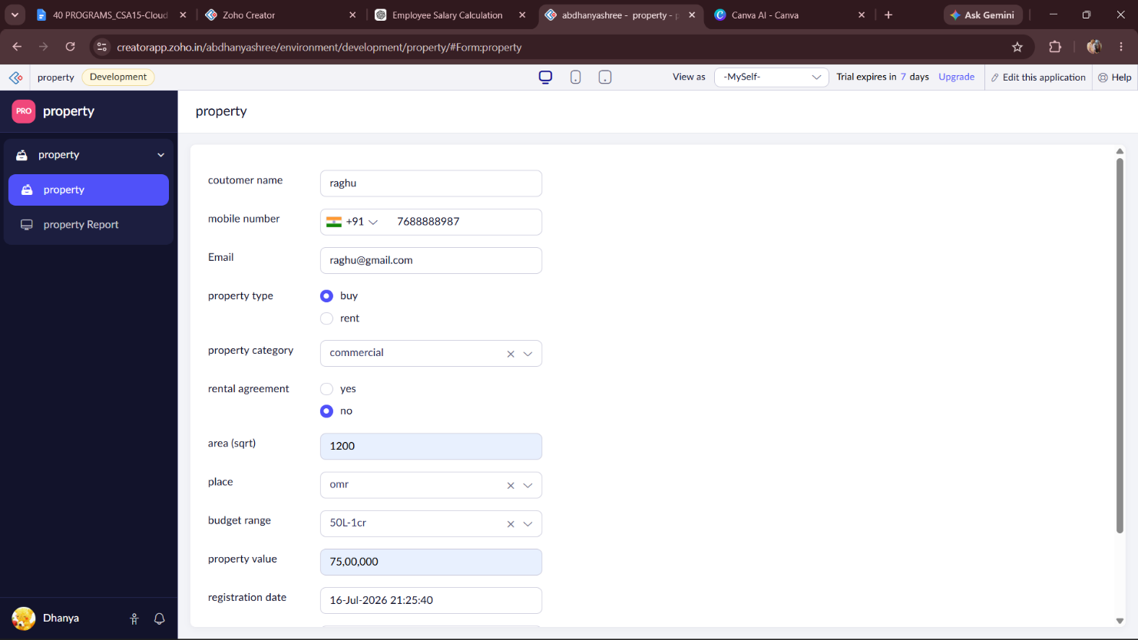
INPUT:

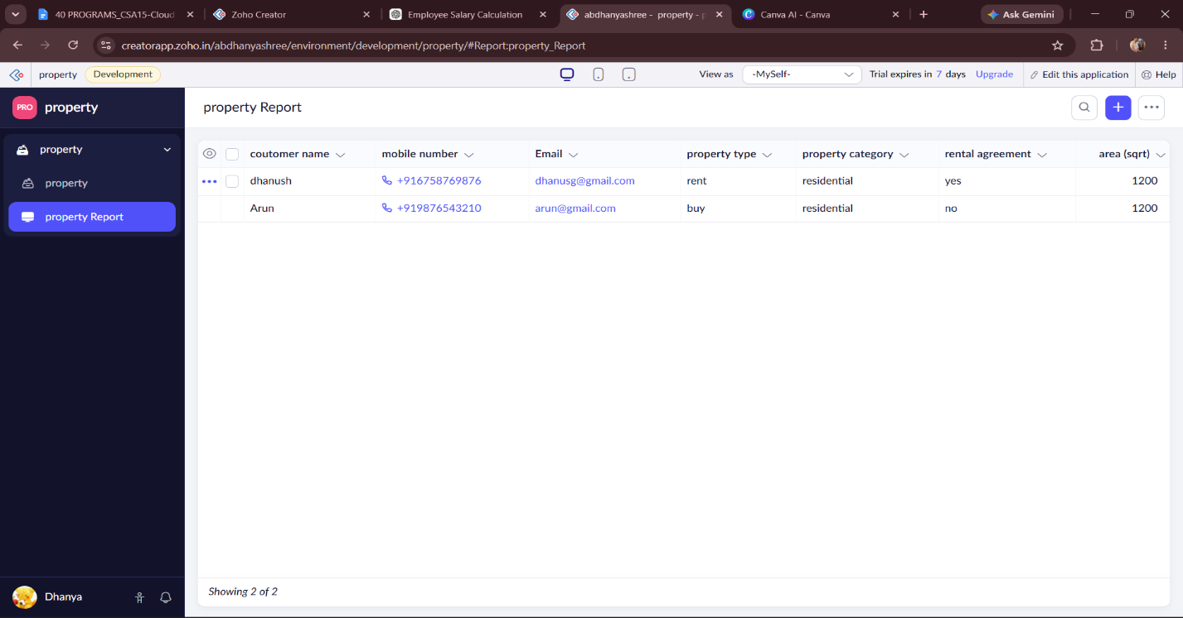
OUTPUT:

DESIGN:
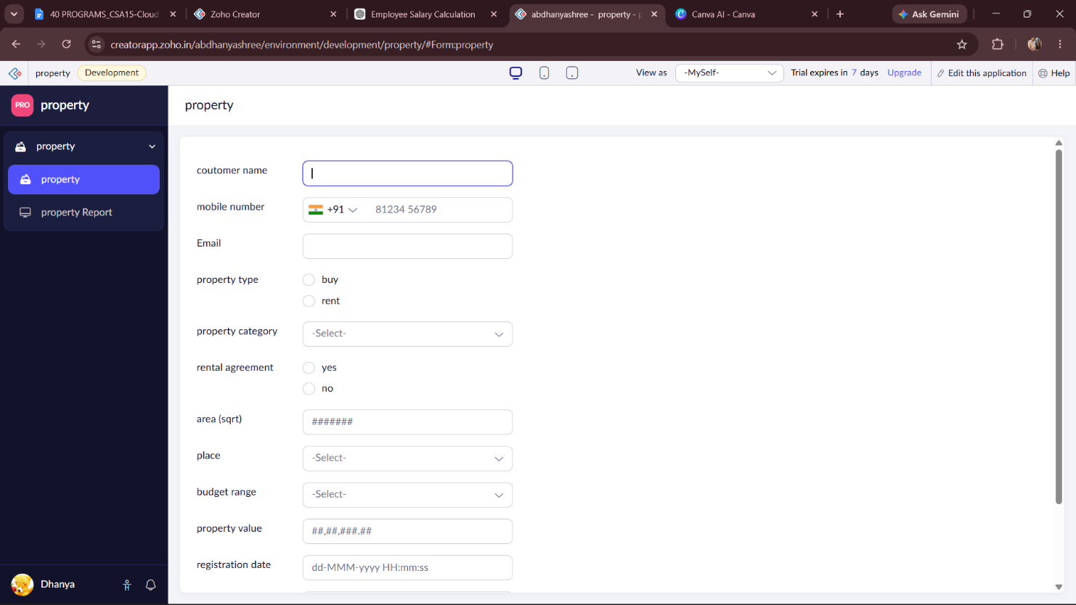

WORKFLOW:
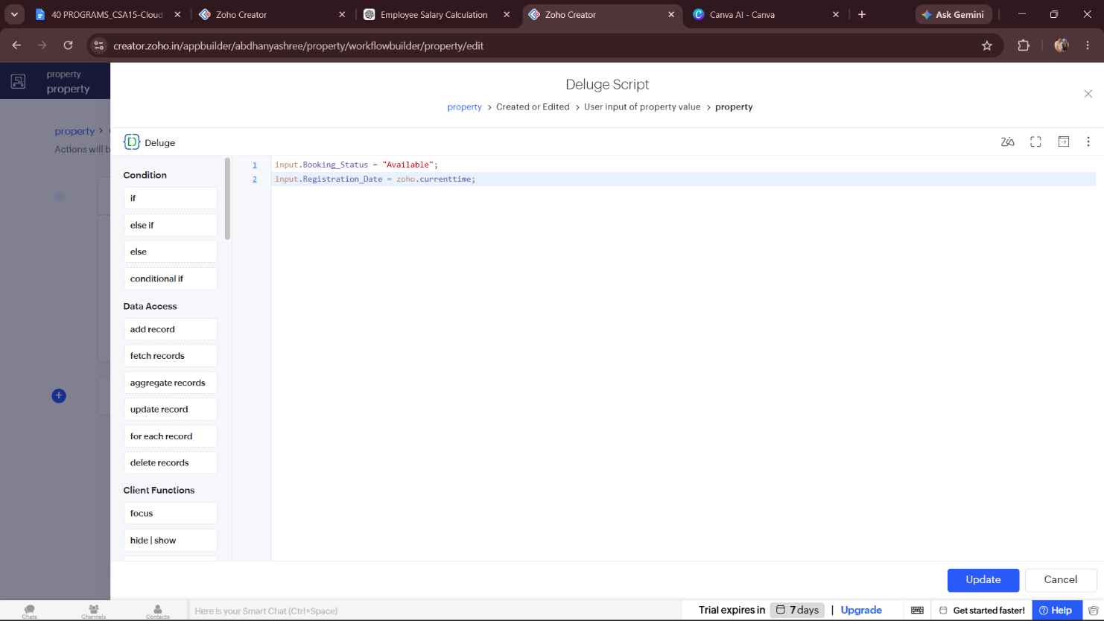

RESULT:
A cloud-based Flight Reservation System was successfully developed using Zoho Creator. The application enables users to book domestic and international flights by entering travel details. The booking date and booking status are updated automatically through workflows, demonstrating the SaaS (Software as a Service) model in cloud computing.

